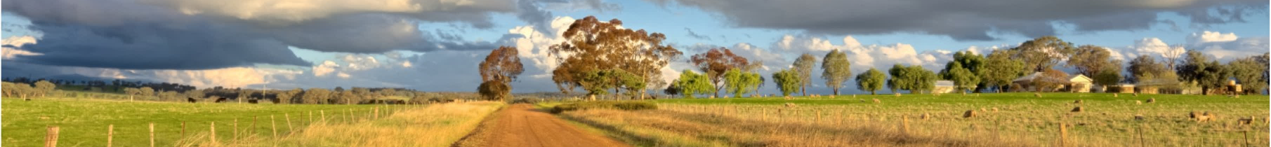
Wede
Breast Cancer
Current trends in Diagnosis and Management

This interactive session will provide an about current trends in the diagnosis and management of breast cancer. The learning outcomes are as follows:

• Understand how to investigate a new breast cancer
• Be able to better interpret histopathology reports
• Understand the scope of oncoplastic breast surgery
• Understand what is and isn’t available locally
• Be able to adequately inform patients about prognosis and treatment options

Presented by:
Dr Neil Meulman | General Surgeon | Bathurst

Date: | Wednesday 30th October 2019
Time: | 6.30pm to 8.30pm
Location: | BATHURST – PHN Conference Room, Ochre Health Building CSU Campus Bathurst
Target Audience: | GPs, Registrars and Medical Students  Nurses, any interested Allied Health or Healthcare Professionals are also welcome.
Program: | 6.30pm - Registration/Light Refreshments (provided)  6.55pm - Welcome  7.00pm - Education Presentation & Case Study Discussion  8.00pm - Interactive Discussion/Q&A  8.30pm - Evaluation and Close
RSVP Date: | 23rd October 2019
Online Registration: | www.wnswphn.org.au/calendar/67/753-CPD-event-Breast-Cancer-Current-trends-in-Diagnosis-and-Management-Bathurst
Further information: | Katie Prior t 6813 0933 e katie.prior@wnswphn.org.au w www.wnswphn.org.au

