Quality Improvement Toolkit
For General Practice
PIP QI TEN MEASURES

PRACTICE INCENTIVE PROGRAM (PIP) QI 10 Measures

Introduction
The Quality Improvement Toolkit
This Quality Improvement (QI) Toolkit is made up of modules that are designed to support your practice to make easy, measurable and sustainable improvements to provide best practice care for your patients. The Toolkit will help your practice complete Quality Improvement (QI) activities using the Model for Improvement.
Throughout the modules you will be guided to explore your data to understand more about your patient population and the pathways of care being provided in your practice. Reflections from the module activities and the related data will inform improvement ideas for you to action using the Model for Improvement.
The Model for Improvement uses the Plan-Do-Study-Act (PDSA) cycle, a tried and tested approach to achieving successful change. It offers the following benefits:
- it is a simple approach that anyone can apply
- it reduces risk by starting small
- it can be used to help plan, develop and implement change that is highly effective.
The Model for Improvement helps you break down your change into manageable pieces, which are then tested to ensure that the change results in measurable improvements, and that minimal effort is wasted.
There is an example using the Model for Improvement and a blank template for you to complete at the end of this module.
If you would like additional support in relation to quality improvement in your practice please contact Western NSW PHN on practicesupportteam@wnswphn.org.au
This icon indicates that the information relates to the ten Practice Incentive Program (PIP) Quality Improvement (QI) measures.

Due to constant developments in research and health guidelines, the information in this document will need to be updated regularly. Please contact Western NSW PHN if you have any feedback regarding the content of this document.

Acknowledgements
We would like to acknowledge that some material contained in this Toolkit has been extracted from organisations including the Institute for Healthcare Improvement, the Royal Australian College of General Practitioners (RACGP); the Australian Government Department of Health; Best Practice; Medical Director, CAT4 and Train IT. These organisations retain copyright over their original work and we have abided by licence terms. Referencing of material is provided throughout.
While the Australian Government Department of Health has contributed to the funding of this material, the information contained in it does not necessarily reflect the views of the Australian Government and is not advice that is provided, or information that is endorsed, by the Australian Government. The Australian Government is not responsible in negligence or otherwise for any injury, loss or damage however arising from the use of or reliance on the information provided herein.
The information in this Toolkit does not constitute medical advice and Western NSW PHN accept no responsibility for information in this toolkit is interpreted or used.
Unless otherwise indicated, material in this booklet is owned by Brisbane South PHN. You are free to copy and communicate the work in its current form, as long as you attribute Brisbane South PHN as the source of the copyright material.

Contents
PRACTICE INCENTIVE PROGRAM (PIP) QI 10 Measures 1
Introduction 1
PIP QI INCENTIVE – 10 MEASURES 4
Quality Improvement 4
PIP QI Incentive 4
PIP QI Improvement Measures 4
How can you check your practice patient data? 4
Activity 1.1 – Data collection from CAT4 5
PIP QI - PRACTICE IMPROVEMENT PLAN 7
Activity 2.1 – Checklist for reflection PIP QI Improvement Measures 7
Activity 2.1 – Reviewing PIP QI Improvement Measures 7
Example PDSA for PIP QI Improvement Measures 8
Using Topbar to assist with patient prompts 9
Instructions - Creating patient prompts to display in Topbar 10
Model for Improvement and PDSA worksheet EXAMPLE 13
Model for Improvement and PDSA worksheet template 16

PIP QI INCENTIVE – 10 MEASURES

Quality Improvement
Quality improvement is foundational to contemporary high performing primary care. It includes team-based approaches, peer review, reflective practice, best practice, and data analysis. It can improve uptake of evidence-based practices for better patient outcomes, better professional development, and better system performance.

PIP QI Incentive
The PIP QI Incentive (PIP QI) is a payment to general practices for activities that support continuous quality improvement in patient outcomes and the delivery of best practice care. General practices enrolled in PIPQI commit to implementing continuous quality improvement activities that support them in their role of managing their patient’s health. They also commit to providing nationally consistent, general practice data, initially in ten key Improvement Measures that contribute to local, regional and national health outcomes. Improvement Measures allow the practice to understand which patients may benefit from preventative treatments, or may need recall to ensure effective management of a specified chronic disease (e.g. Type 2 Diabetes). This can help delay progression of the condition, improve quality of life, increase life expectancy, and decrease the need for high cost interventions.

PIP QI Improvement Measures
The collection of the de-identified Improvement Measures that form the PIP Eligible Data Set are part of a system of quality improvement that includes reflective practice, a common data baseline, and data analysis. The Improvement Measures are not designed to assess individual general practice or general practitioner performance. They do support a regional and national understanding of chronic disease management in areas of high need, and future iterations will respond to emerging evidence on areas of high need. The first tranche of Improvement Measures are:

1. Proportion of patients with diabetes with a current HbA1c result
2. Proportion of patients with a smoking status
3. Proportion of patients with a weight classification
4. Proportion of patients aged 65 and over who were immunised against influenza
5. Proportion of patients with diabetes who were immunised against influenza
6. Proportion of patients with COPD who were immunised against influenza
7. Proportion of patients with an alcohol consumption status
8. Proportion of patients with the necessary risk factors assessed to enable CVD assessment
9. Proportion of female patients with an up-to-date cervical screening
10. Proportion of patients with diabetes with a blood pressure result

How can you check your practice patient data?

It’s important from a practice perspective to review your data and systems to identify if you are meeting targets.
There are 2 options you can choose from to obtain this information:

Option 1: Data Collection from CAT4 – please refer to the CAT4 recipes on http://help.pencs.com.au/display/CR/CAT+RECIPES
Or Option 2: Refer to your Benchmark report as provided by Western NSW PHN

Activity 1.1 – Data collection from CAT4
Complete the below table by collecting data from your CAT4 Data Extraction Tool.
Note - Instructions on how to extract the data is available from the PenCS website: http://help.pencs.com.au/display/CR/CAT+RECIPES .
The aim of this activity is to collect data to determine the number of patients in your practice according to the Improvement Measures as per the PIP QI guidelines.

 | Description | Total Number | Current % of patient’s achieving the measures | Goal/target to improve
1.1 | Number of active patients with Type 1 or Type 2 Diabetes
1.2 | Number of active patients with Type 1 or Type 2 Diabetes who have had an HbA1c in the past 12 months - PenCS Instructions - in conditions under Diabetes, select Type 1 or Type II Instead of all diabetes
1.3 | Number of active patients aged 15 years and over
1.4 | Number of active patients aged 15 years and over whose smoking status has been recorded as one of the following: current smoker; ex-smoker; or never smoked. PenCS Instructions
1.5 | Number of active aged 15 years and over and who have had their Body Mass Index (BMI) classified as obese, overweight, healthy, or underweight within the previous 12 months. PenCS Instructions
1.6 | Number of active patients aged 65 years and over
1.7 | Number of active patients aged 65 years and over who were immunised against influenza in the previous 15 months.
1.8 | Number of active patients with diabetes who were immunised against influenza in the previous 15 months. PenCS Instructions
1.9 | Number of active patients who are aged 15 years and over, are recorded as having chronic obstructive pulmonary disease (COPD), and were immunised against influenza in the previous 15 months. PenCS Instructions
1.10 | Number of active patients who are aged 15 years and over who have had their alcohol consumption status recorded.
1.11 | Number of active patients aged 45 to 74 years
1.12 | Number of active patients aged 45 to 74 years with information available to calculate their absolute CVD risk. This includes tobacco smoking, Diabetes, Systolic blood pressure, Total cholesterol and HDL cholesterol levels, Age and Gender PenCS Instructions
1.13 | Number of active female patients aged 20 to 74 years.  The age 20 is to capture people on the PAP system which will be transitioning until 1st December 2019.
1.14 | Number of active female patients aged 20 to 74 years, who have not had a hysterectomy and who have had a cervical screening [either Papanicolaou smear (Pap test) within the previous 2 years, or human papillomavirus (HPV) test] within the previous 5 years. PenCS Instructions
1.15 | Number of active patients who have diabetes and who have had a blood pressure measurement result recorded PenCS Instructions - change the condition from CVD to Diabetes
Please note: to work out percentage divide the number of patients with the data measures completed by the total age population and then multiply by 100. (For e.g. If your practice has 334 patients with Type 1 or Type II diabetes and only 277 have had a HbA1c completed in the past 12 months, 277 divided by 334 multiply by 100)
Reflection comments as a result of completing Activity 1.1:
Practice name: Date:
Team member:

PIP QI - PRACTICE IMPROVEMENT PLAN

Activity 2.1 – Checklist for reflection PIP QI Improvement Measures
Complete the checklist below to review your practice’s data to meet the PIP QI Improvement Measures.

Activity 2.1 – Reviewing PIP QI Improvement Measures
 | Status | Action to be taken
After reviewing your PIP QI Improvement Measures are there any unexpected results? | Yes, see action to be taken  No, continue with activity | What observations have you made?  What action will you take?  How will you use this information to improve the numbers?
Do you know the contact details for the Practice Incentive Payment Program for any PIP QI related questions? | Yes, continue with activity  No, see actions to be taken | PIP QI Email: pip@humanservices.gov.au  PIP QI Enquiry Line - 1800 222 032
Are there any changes with the PIP QI improvement measures you would like to implement over the next 12 months? | Yes, set goals and outline in actions to be taken  No, continue with activity | Refer to the Model for Improvement to help set goals at the end of this module.

Reflection comments as a result of completing Activity 2.1:
Practice name: Date:
Team member:

Example PDSA for PIP QI Improvement Measures
If you identified in activity 2.1 that you would like to implement some changes within your practice to improve your practices results on the 10 PIP QI Improvement Measures, then it is recommended that you use the Model for Improvement worksheet at the end of this document to guide you to make successful changes.
The Model for Improvement provides a framework for developing, testing and implementing changes in a way that will lead to improvement.
See below for suggested goals related to the PIP QI measures you may wish to achieve within your practice:
Goal | How you may achieve the goal
Ensure all active patients with diabetes are coded correctly and have a HbA1c recorded in the past 12 months | Refer to PENCS on identifying patients with diabetes with no HbA1c recorded in the past 12 months
Ensure 90% of active patients aged 15 years and older have smoking status – current smoker, ex-smoker or never smoked | Refer to PENCS on identifying patients with no allergy or smoking status recorded
Ensure 75% of active patients aged 15 years and older have BMI classified as obese, overweight, healthy or underweight within the previous 12 months | Refer to PENCS – adding, height, weight and waist measurements to patients records
Increase the number of flu injections given to active patients aged 65 years and over the past 15 months by 10% | Refer to PENCS to identify the number of active patients 65 years and over who have not received a flu injection in the past 15 months
Increase the number of flu injections given to diabetes patient over the past 15 months by 10% | Refer to PENCS to identify the number of diabetes patients who have not received a flu injection in the past 15 months
Increase the number of flu injections given to patients with COPD over the past 15 months by 5% | Refer to PENCS to identify the number of COPD patients who have not received a flu injection in the past 15 months
Ensure 90% of active patients aged 15 years and older have their alcohol status recorded | Refer to cat4 data to identify the list of patients who do not have their alcohol status recorded
Increase by 10% the number of patients aged 45 to 74 years with the following:  Smoking status  Blood pressure  Total cholesterol and HDL levels  (you may wish to do this as part of a healthy heart check MBS item 699) | Refer to CAT4 data to:  identify patients with no allergy or smoking status recorded  Identify patients with no BP recorded  Identify patients with no cholesterol and HDL levels recorded
Increase the cervical screening of the number of eligible female patients aged 20 to 74 years by 10%  NB: the age 20 is to capture people on the pap system which will be transitioning until 1st December 2019. | Refer to cat4 data to find patients eligible for cervical screening
Ensure that 90% of active diabetes patients have their blood pressure recorded | Refer to cat4 data to find patients with CVD with no BP recorded – please note: you will be required to select diabetes instead of CVD

Other ideas:
- Ask the practice nurse to opportunistically see patients prior to their GP appointment to obtain height, weight, waist measurements, BP, smoking and alcohol status; OR
- Ask patients to complete a summarised new patient form with their height, weight, waist measurements, BP, smoking and alcohol status and also check their address, contact details, NOK and emergency contact
- Develop a reminder list e.g.: proactively contact patients with COPD who have not yet had their flu injection
- Ensure Topbar is installed on every workstation and fully operational

Using Topbar to assist with patient prompts
Topbar prompts administrative and clinical staff to opportunistically capture missing demographic or clinical information at the point of care. It can play a significant role in improving general practice data quality, chronic disease management and eHealth. Topbar is available for practices using Best Practice, MD3 or ZedMed software.
Topbar has four main applications that can be tailored to meet the practice needs.
- The Waiting Room App provides staff with a quick view of patients who are currently in the waiting room and missing demographic or clinical data.
- The Cleansing App provides the clinician with a quick view of the patients’ record and highlights missing demographic and clinical information.
- The MBS App shows recommended actions and claim status relating to the Medicare Benefits Schedule (MBS).
- The Patient Health Summary App displays information from the patients’ medical record and displays it in chronological order.
Click here to access the Topbar Apps

Instructions - Creating patient prompts to display in Topbar
Remember you need to be in the CAT4 Daily View (see picture below) to be able to create prompts.
Other pre-requisites are:
- Topbar is installed
- CAT4 is linked to Topbar via Edit/Preferences/Topbar
To start CAT4 in the Daily View, click on the 'Daily View' icon in the dashboard:
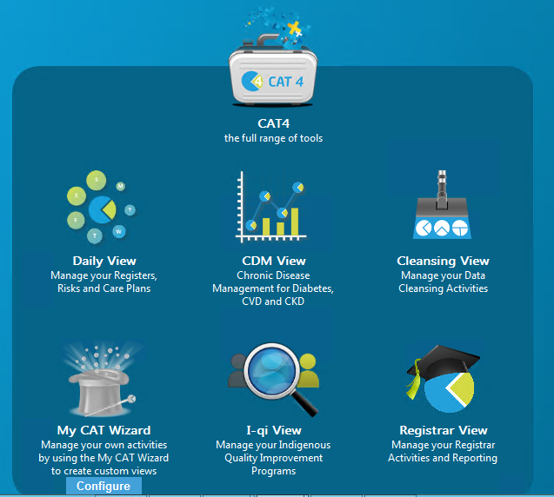
Once you have applied the filter(s) (active patients, medical condition, and smoking status etc. – refer to relevant CAT4 recipe) and exported the report, the patients of interest will be displayed. From there you can create a prompt that will be shown to all clinicians using Topbar if a patient meeting the prompt criteria is opened in their clinical system.

To start, after you have created the report you have to click on the Topbar prompt icon and the bottom right hand corner.
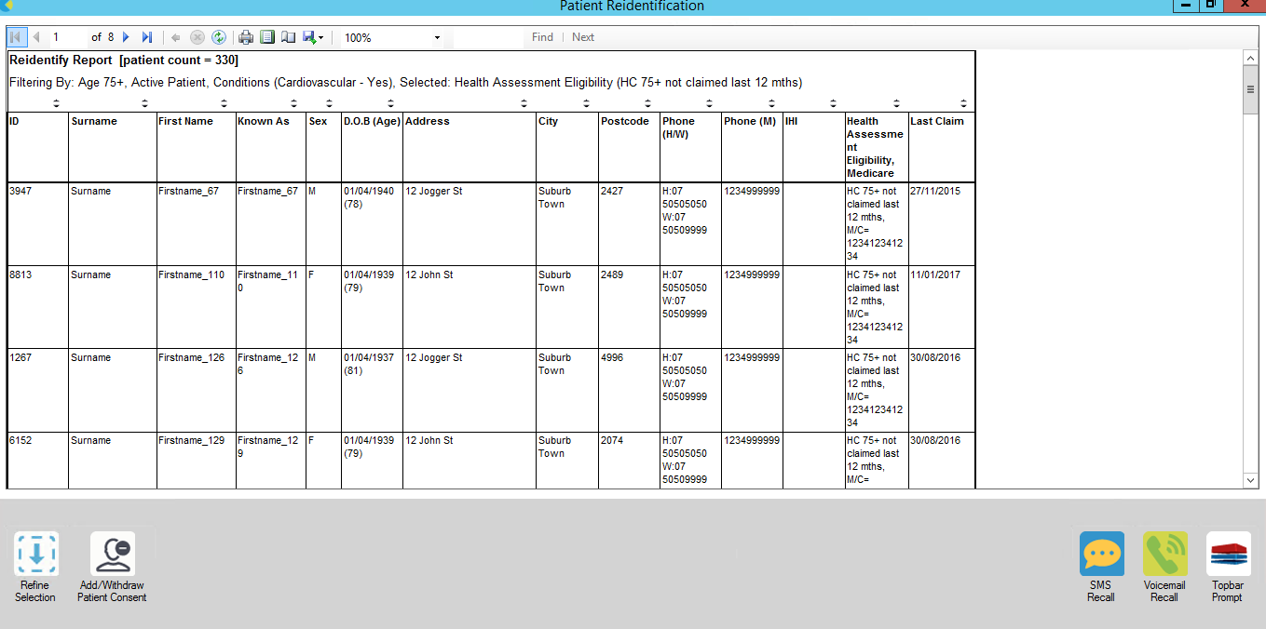
Use the drop-down menu at the bottom of the patient details report and select "Prompt at Consult - Topbar" then click on "Go" to give the new prompt a name.
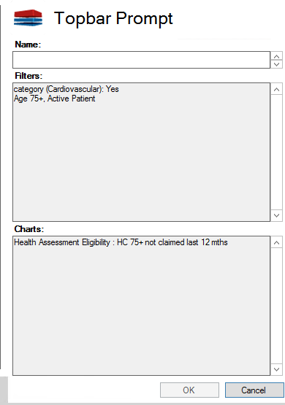
To access more information about Topbar please refer to the website
Additional Resources

RACGP General Practice Management Toolkit – Managing Quality
PIP QI Guidelines
PIP Improvement Measures
PIP Eligible Data Set Data Governance Framework
PIP QI Who do I ask
PIP QI FAQs
Change Program Toolkit

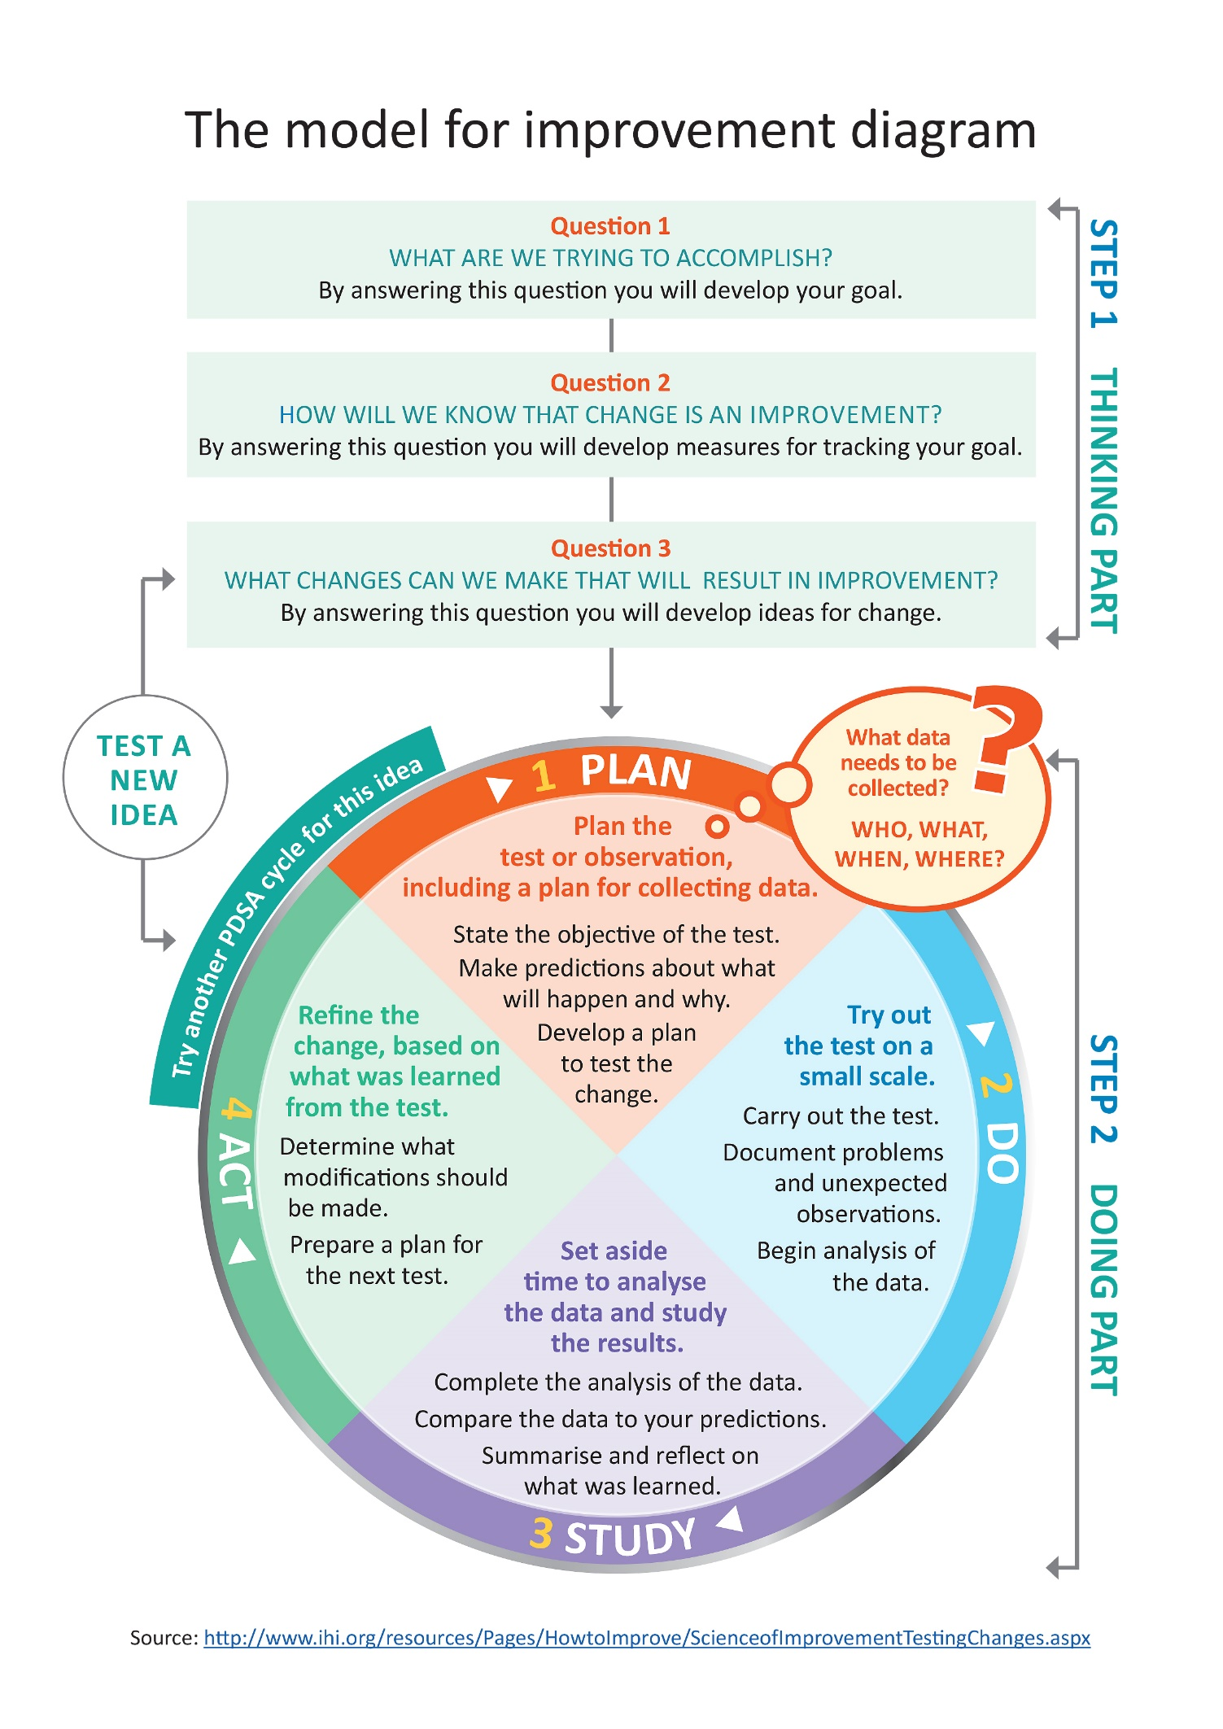

Model for Improvement and PDSA worksheet EXAMPLE

Step 1: The Thinking Part - The 3 Fundamental Questions

Practice name: | Date:
Team member:
Q1. What are we trying to accomplish? (Goal)
By answering this question, you will develop your goal for improvement
Our goal is to:
- Ensure patients who have a diagnosis of COPD receive an influenza vaccine.
This is a good start, but how will you measure whether you have achieved this goal? The team will be more likely to embrace change if the goal is more specific and has a time limit.
So, for this example, a better goal statement would be:
Our S.M.A.R.T. goal is to:
- Increase the proportion of our active patients with COPD who have an influenza vaccine by 20% by 31 July.
Q2. How will you know that a change is an improvement? (Measure)
By answering this question, you will develop MEASURES to track the achievement of your goal.
E.g. Track baseline measurement and compare results at the end of the improvement.
We will measure the percentage of active patients with COPD who have had a flu vaccine. To do this we will:
A) Identify the number of active patients with COPD
B) Identify the number of active patients with COPD who have had a vaccine
B divided by A x 100 produces the percentage of patients with COPD who have had a flu vaccine
Q3. What changes could we make that will lead to an improvement? (List your IDEAS)
By answering this question, you will develop the IDEAS that you can test to achieve your CHANGE goal.
You may wish to BRAINSTORM ideas with members of our Practice Team.
Our ideas for change:
- Using CAT4, identify active patients with COPD who have not had a flu vaccine this year
- Identify patients from list exported from CAT4 and send SMS recall via hot docs
- Check vaccine stock, reorder if available
- Source and provide endorsed patient education resources on flu vaccination (in waiting rooms, etc)
- Run an awareness campaign for COPD
The team selects one idea to begin testing with a PDSA cycle

Note: Each new GOAL (1st Fundamental Question) will require a new Model for Improvement Guide
Source: Langley, G., Nolan, K., Nolan, T., Norman, C. & Provost, L. 1996, The Improvement Guide, Jossey-Bass, San Francisco, USA.

Model for Improvement and PDSA worksheet EXAMPLE

Step 2: The Doing Part - Plan, Do, Study, Act
You will have noted your IDEAS for testing when you answered the third Fundamental Question in Step 1
You will use this sheet to test an idea.

PLAN |  |  | Describe the brainstorm idea you are planning to work on. (Idea)
Plan the test, including a plan for collecting data |  |  | What exactly will you do? include what, who, when, where, predictions and data to be collected
Idea: Identify active patients with COPD who have not had a flu vaccine recorded this year.
What: Mary will conduct a search on CAT4 and identify active patients with COPD who have not had a flu vaccine recorded this year.
Who: Receptionist (Mary)
When: Begin 20 May
Where: at the practice in Dr Bills room
Prediction: 60% of the active COPD patient population will have had their flu vaccine recoded this year.
Data to be collected: Number of active COPD patients and number of active COPD patients who have not had a flu vaccine recorded this year.
DO | Who is going to do what? (Action)
Run the test on a small scale | How will you measure the outcome of your change?
Completed 20 May – the receptionist contacted Western NSW PHN for support with the PenCS CAT4 search and the export function. The data search was conducted very quickly, with the receptionist being upskilled to conduct further relevant searches.
STUDY |  | Does the data show a change? (Reflection)
Analyse the results and compare them to your predictions |  | Was the plan executed successfully?  Did you encounter any problems or difficulty?
A total of 40 active patients (50%) with COPD have had their influenza vaccine status recorded this year = 10% lower than predicted.
ACT |  |  |  | Do you need to make changes to your original plan? (What next)  OR Did everything go well?
Based on what you learned from the test, plan for your next step |  |  |  | If this idea was successful you may like to implement this change on a larger scale or try something new  If the idea did not meet its overall goal, consider why not and identify what can be done to improve performance
- Identify patients from list exported from CAT4 and send SMS recall
- Create a PenCS Topbar prompt to ensure all patients with COPD have a flu vaccine offered and result recorded at their next appointment. Review this by 31 July (in two months’ time) to determine if there has been an increase in the number of patients with flu vaccine status recorded.
- Ensure the clinical team know where to record the vaccine status in the medical software.
- Remind the whole team that this is an area of focus for the practice.

Repeat Step 2 for other ideas – What idea will you test next?

Model for Improvement and PDSA worksheet template

Step 1: The Thinking Part - The 3 Fundamental Questions

Practice name: | Date:
Team member:
Q1. What are we trying to accomplish? (Goal)
By answering this question, you will develop your GOAL for improvement
Q2. How will you know that a change is an improvement? (Measure)
By answering this question, you will develop MEASURES to track the achievement of your goal.
E.g. Track baseline measurement and compare results at the end of the improvement.
Q3. What changes could we make that will lead to an improvement? (List your IDEAS)
By answering this question, you will develop the IDEAS that you can test to achieve your CHANGE goal.
You may wish to BRAINSTORM ideas with members of our Practice Team.
Idea:

Idea:

Idea:

Idea:

Note: Each new GOAL (1st Fundamental Question) will require a new Model for Improvement plan.
Source: Langley, G., Nolan, K., Nolan, T., Norman, C. & Provost, L. 1996, The Improvement Guide, Jossey-Bass, San Francisco, USA.

Model for Improvement and PDSA worksheet template

Step 2: The Doing Part - Plan, Do, Study, Act cycle
You will have noted your IDEAS for testing when you answered the third Fundamental Question in Step 1
You will use this sheet to test an idea.

PLAN | Describe the brainstorm idea you are planning to work on. (Idea)
Plan the test, including a plan for collecting data | What exactly will you do? Include what, who, when, where, predictions and data to be collected
DO | Who is going to do what? (Action)
Run the test on a small scale | How will you measure the outcome of your change?
STUDY | Does the data show a change? (Reflection)
Analyse the results and compare them to your predictions | Was the plan executed successfully?  Did you encounter any problems or difficulty?
ACT | Do you need to make changes to your original plan? (What next)  OR Did everything go well?
Based on what you learned from the test, plan for your next step | If this idea was successful you may like to implement this change on a larger scale or try something new.  If the idea did not meet its overall goal, consider why not and identify what can be done to improve performance.
Repeat Step 2 for other ideas - What idea will you test next?
First floor, Building 20, Garden City Office Park, 2404 Logan Road, Eight Mile Plains QLD 4113
PO Box 6435, Upper Mt Gravatt QLD 4122 T: 3864 7555 or 1300 467 265 | F: 3864 7599
bsphn.org.au | ABN 53 151 707 765

