- Know your patient demographics
- DVA & Concession cards
- Patients on 5 or more medications
- Aboriginal & Torres Strait Islander patients
- Your practice’s cultural profile

Patient population groups
Quality Improvement Toolkit
For General Practice

PATIENT POPULATION GROUPS

Introduction
The Quality Improvement Toolkit
This Quality Improvement (QI) Toolkit is made up of modules that are designed to support your practice to make easy, measurable and sustainable improvements to provide best practice care for your patients. The Toolkit will help your practice complete Quality Improvement (QI) activities using the Model for Improvement.
Throughout the modules you will be guided to explore your data to understand more about your patient population and the pathways of care being provided in your practice. Reflections from the module activities and the related data will inform improvement ideas for you to action using the Model for Improvement.
The Model for Improvement uses the Plan-Do-Study-Act (PDSA) cycle, a tried and tested approach to achieving successful change. It offers the following benefits:
- it is a simple approach that anyone can apply
- it reduces risk by starting small
- it can be used to help plan, develop and implement change that is highly effective.
The Model for Improvement helps you break down your change into manageable pieces, which are then tested to ensure that the change results in measurable improvements, and that minimal effort is wasted.
There is an example using the Model for Improvement and a blank template for you to complete at the end of this module.
If you would like additional support in relation to quality improvement in your practice please contact Western NSW PHN on practicesupportteam@wnswphn.org.au
This icon indicates that the information relates to the ten Practice Incentive Program (PIP) Quality Improvement (QI) measures.

Due to constant developments in research and health guidelines, the information in this document will need to be updated regularly. Please contact Western NSW PHN if you have any feedback regarding the content of this document.
Acknowledgements
We would like to acknowledge that some material contained in this Toolkit has been extracted from organisations including the Institute for Healthcare Improvement, the Royal Australian College of General Practitioners (RACGP); the Australian Government Department of Health; Best Practice; Medical Director, CAT4 and Train IT. These organisations retain copyright over their original work and we have abided by licence terms. Referencing of material is provided throughout.
While the Australian Government Department of Health has contributed to the funding of this material, the information contained in it does not necessarily reflect the views of the Australian Government and is not advice that is provided, or information that is endorsed, by the Australian Government. The Australian Government is not responsible in negligence or otherwise for any injury, loss or damage however arising from the use of or reliance on the information provided herein.
The information in this Toolkit does not constitute medical advice and Western NSW PHN accept no responsibility for information in this toolkit is interpreted or used.
Unless otherwise indicated, material in this booklet is owned by Brisbane South PHN. You are free to copy and communicate the work in its current form, as long as you attribute Brisbane South PHN as the source of the copyright material.

Contents
PATIENT POPULATION GROUPS 1
Introduction 1
PATIENT POPULATION GROUPS 5
Who are your patients? Look at your patient demographics 5
Activity 1.1 – Data collection from CAT4 5
Activity 1.2 – Understanding your practice population 6
Instructions – Reviewing your practice database with Topbar 7
Pensioners, Department of Veterans’ Affairs (DVA) and the Coordinated Veterans' Care (CVC) Program 8
Type of concession cards 8
Veterans’ Health 8
Activity 2.1 – Data Collection from CAT4 8
What is bulk billing? 9
Veterans and bulk billing 9
Why do practices need to know this information? 9
Ensuring patient concession information is entered into MD/Pracsoft 9
Ensuring patient concession information is entered into Best Practice 10
Activity 2.2 – Updating patient’s concession details 10
Practice fees and RACGP Accreditation standards 11
Activity 2.3 – Notifying patients of practice billing procedures 12
DVA Changes to Gold Card referrals to allied health professionals 13
DVA patients and the CVC Program 13
Identifying patients eligible for the CVC program 13
PATIENTS ON 5 OR MORE MEDICATIONS 13
Medication management reviews 14
Activity 3.1 – Data collection from CAT4 14
ABORIGINAL AND TORRES STRAIT ISLANDER PATIENTS 15
Activity 4.1 – Data collection from CAT4 15
PIP registration and PBS co-payment 15
Table 1: Payments and requirements of the PIP Indigenous Health Incentive 16
Activity 4.2 – PIP Indigenous Health Incentive 16
Updating CTG PBS co-payment patient registration in Best Practice 18
Updating CTG PBS co-payment patient registration in Medical Director 19
Cultural awareness training 19
Activity 4.3 – Cultural awareness training and your practice 20
Topics to consider 20
Status 20
Action to be taken 20
Understanding your practice’s cultural profile 21
RACGP 5th edition Accreditation Standards 21
Number of patients with Country of birth and/or ethnicity recorded 21
Activity 5.1 – Data collection from CAT4 21
Activity 5.2 – Understanding your practice’s cultural profile 22
Instructions – Recording ethnicity and country of birth in your clinical software (Medical Director) 23
Entering ethnicity information in the patient file in Medical Director 23
Entering country of birth in the patient file in Medical Director 24
Instructions – Recording ethnicity in your clinical software (Best Practice) 25
Activity 5.3 – Interpreter services 27
Activity 5.3 – Interpreter services 27
Cultural competence training 29
Activity 5.4 - Referrals to other health professionals 30
Activity 5.4 – Patient referrals 30
Updating Personal Details in Medical Director 31
Model for Improvement and PDSA worksheet EXAMPLE 33
Model for Improvement and PDSA worksheet template 36
Step 1: The Thinking Part - The 3 Fundamental Questions 36
Step 2: The Doing Part - Plan, Do, Study, Act cycle 37

PATIENT POPULATION GROUPS

Who are your patients? Look at your patient demographics
According to the RACGP Accreditation Standards, an ‘active patient’ is a patient who has attended the practice/service three or more times in the past 2 years

Activity 1.1 – Data collection from CAT4
Complete the below table by collecting data from your CAT4 Data Extraction Tool. You may also refer to the Western NSW PHN SA3 profile for your practice region to provide insights into population health priorities and compare this with your practice data
Note - Instructions on how to extract the data is available from the PenCS website: https://help.pencs.com.au/pages/viewpage.action?pageId=1476486 . or from the monthly Benchmarking report as provided by Western NSW PHN
The aim of this activity is to collect data to determine the demographics of your practice’s active patient population

 | Description | Total number
1.1 | Total practice population
1.2 | Number of active patients (i.e.: 3 x visits in 2 years)
1.3 | Number of active female patients
1.4 | Number of active male patients
1.5 | Number of active patients aged 0 to 19 years
1.6 | Number of active patients aged 20 to 39 years
1.7 | Number of active patients aged 40 to 49 years
1.8 | Number of active patients aged 50 to 64 years
1.9 | Number of active patients aged 65 to 74 years
1.10 | Number of active patients aged 75 years and greater

Reflection comments as a result of completing Activity 1.1:
Practice name: Date:
Team member:

Activity 1.2 – Understanding your practice population
The aim of this activity is to increase your understanding of the active patient population.
Description | Status | Action to be taken
After completing activity 1.1 are there any unexpected results with your practice’s patient demographics? | Yes: see actions to be taken  No: continue with activity | Please explain: (for e.g. higher older population than expected, practice has a low population of people between 40 and 49 years)  How will this information be communicated to the practice team?
Is your practice demographics similar to other practices in the Brisbane South region (compare information from Benchmark report)? | Yes: continue with activity  No: see action to be taken | Outline the differences – is it active population, age group differences, male/female populations?  How will this information be communicated to the practice team?
After reviewing your patient demographics, are there any changes you would like to implement in the practice, to help manage patients, over the next 12 months? | Yes, see “actions to be taken” to help set you goals.  No, continue with activity. | Refer to the Model for Improvement (MFI) and the “Thinking part” at the end of this document.  Refer to the “Doing part - PDSA” of the Model for Improvement (MFI) to test and measure your ideas for success.

Reflection comments as a result of completing Activity 1.2:
Practice name: Date:
Team member:

Instructions – Reviewing your practice database with Topbar

PenCS have options to assist with reviewing your practice database.
- Using TOPBAR to identify missing demographic details. The Demographic tab will display any missing and completed items from the patients record related to their demographic information in their patient record in the GP application.
- TOPBAR cleansing app This tab displays any missing and completed items from the patients record related to their demographic information in their patient record in the GP application. Items that require actions are displayed on top and completed items at the bottom of the screen.

Pensioners, Department of Veterans’ Affairs (DVA) and the Coordinated Veterans' Care (CVC) Program

Type of concession cards
Patients may be entitled to a variety of concession cards. The Department of Human Services provides a list of the different types of cards available and eligible criteria.

DVA issues health cards to eligible veterans and former members of the Australian Defence Force (ADF), their widow(er)s and dependants. There are different eligibility requirements and benefits for each type of card.
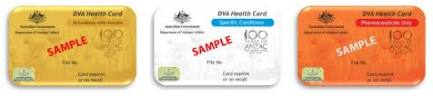

Veterans’ Health

Activity 2.1 – Data Collection from CAT4
Complete the below table by collecting data from your CAT4 Data Extraction Tool.
Note - Instructions on how to extract the data is available from the PenCS website: https://help.pencs.com.au/display/CR/Identify+DVA+patients+eligible+for+Coordinated+Veterans+Care
The aim of this activity is to collect data to determine the number of DVA card holder’s the practice has

 | Description | Total number
2.1 | Total active population
2.2 | Total active population with a DVA card

What is bulk billing?
Bulk billing means the patient does not have to pay for their medical service from a GP or specialist. The GP or specialist bills Medicare instead and accepts the Medicare benefit as full payment for the service. Not all GPs and specialists bulk bill. Private billing means the patient pays for their medical service with the GP or specialist. The patient may be able to claim some of the money back from Medicare.

Veterans and bulk billing
Providers who accept health cards are registered by the Australian Government and, as a requirement of accepting the cards, agree to accept DVA's scheduled fee as full payment for the services. No medical health provider should charge a DVA health card holder a gap fee.

Why do practices need to know this information?
It’s important to understand why your practice needs to have concession and Medicare card details up to date. This can be for:
- Specific health care needs, especially of the ageing population;
- Socio-economic status of your patients;
- Additional bulk billing incentives available from Medicare;
- Concession fees on medications for patients from the Pharmaceutical Benefit Scheme
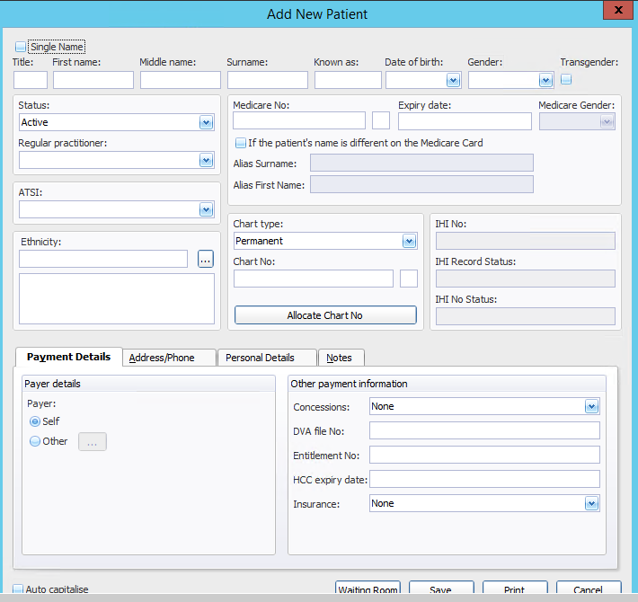
More information about claiming bulk bill incentives can be found at the Medicare Education Guide

Ensuring patient concession information is entered into MD/Pracsoft
If the patient’s up to date concession details are entered in the other payment information section on Pracsoft, this will trigger adding the Medicare Bulk Billing incentive item 10990 as appropriate.

For full details of entering information into Pracsoft see the user guide

Ensuring patient concession information is entered into Best Practice
If the patient’s up to date concession details are entered in the other payment information section on Best Practice, this will trigger adding the Medicare Bulk Billing incentive item 10990 as appropriate.
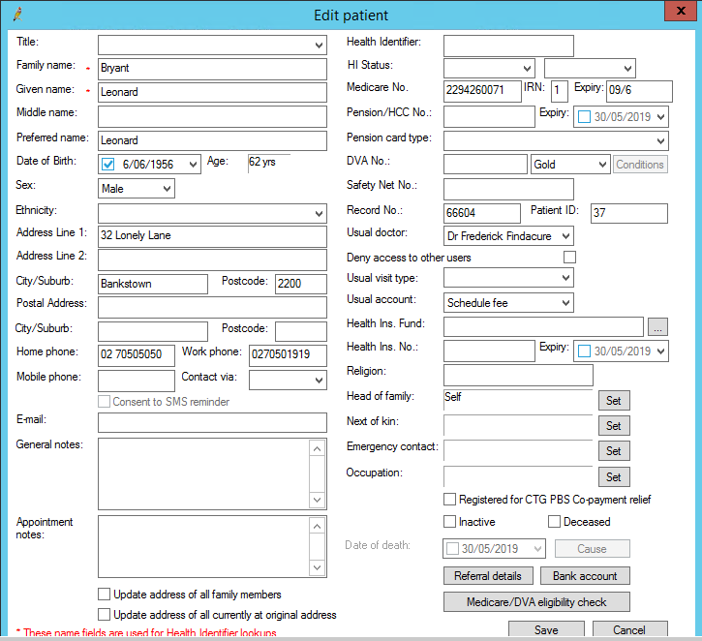
For full details of entering information into Best Practice see the user guide

Activity 2.2 – Updating patient’s concession details
Description | Status | Action to be taken
Do all relevant staff know where to enter patient’s Medicare and concession details into the billing software | Yes: continue with activity  No: see action to be taken | Communicate to relevant practice team members how to enter this information
Does the practice check at each appointment Medicare card and concession card details? | Yes: continue with activity  No: see action to be taken | Consider when the patient is arriving for their appointment, ask to view Medicare and any relevant concession cards
Do relevant staff understand the GP/practice receives an additional payment if eligible patients are bulk billed? | Yes: you have completed this activity  No: see action to be taken | Provide education to relevant staff  Discuss at practice meetings regularly  Medicare education guide
Reflection comments as a result of completing Activity 2.2:
Practice name: Date:
Team member:

Practice fees and RACGP Accreditation standards
According to the 5th edition RACGP Accreditation Standards, practices are required to provide information to cost of services provided by the practice.
C1.1 A. Our patients can access up-to-date information about the practice.

At a minimum, this information contains:
- our practice’s address and telephone numbers
- our consulting hours and details of arrangements for care outside normal opening hours
- our practice’s billing principles

Meeting this criterion
You can provide this information in many formats, such as:
- printed information sheets
- on the practice’s website.
- Practice newsletter
Pictures and simple language versions help patients who would otherwise be unable to read or understand the information. The practice needs to update this information regularly so that it remains accurate. Ideally, the information is updated as soon as it changes.

Activity 2.3 – Notifying patients of practice billing procedures

Description | Status | Action to be taken
Do all staff know the practice’s billing procedures (i.e.: is bulk billing available, do patients know the standard consultation fee?) | Yes: continue with activity  No: see action to be taken | Communicate to relevant practice team members the practice billing procedures
Are patient’s informed of practice billing procedures? | Yes: outline methods of communication  No: see action to be taken to identify what methods your practice will use | Waiting room poster  Practice newsletter  Practice website  Notified when making appointment  Other: ______________________________  _____________________________________

Reflection comments as a result of completing Activity 2.3:
Practice name: Date:
Team member:

DVA Changes to Gold Card referrals to allied health professionals
The way that a General Practitioner (GP) refers DVA patients to allied health providers is set to change from July 2019. To keep up to date with these changes please refer to https://www.dva.gov.au/providers/dva-provider-news/changes-process-allied-health-referrals

DVA patients and the CVC Program
The Department of Veterans' Affairs' Coordinated Veterans' Care (CVC) Program uses a proactive approach to improve the management of participants' chronic conditions and quality of care.
CVC is a team-based program where the participant, a General Practitioner (GP) and a nurse coordinator (NC) work together as a core team to develop a plan to meet the health needs of the participant and manage their ongoing care.
More information about the CVC program can be found at: https://www.dva.gov.au/providers/provider-programs/coordinated-veterans-care/coordinated-veterans-care-providers

Identifying patients eligible for the CVC program
To search CAT4, click on the “CAT4” icon in the dashboard:

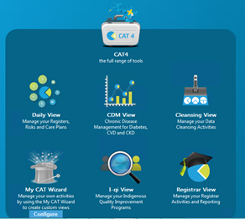
CAT4 has a recipe available to assist practices to identify DVA patients eligible for the CVC program. To access this recipe:

CAT4 searches to identify DVA patients eligible for CVC program

PATIENTS ON 5 OR MORE MEDICATIONS
Medication errors are a problem in Australia, as they are in other countries. Previous estimates indicate between 2% and 3% of all Australian hospital admissions are medication-related. This suggests at least 230,000 admissions annually in this country are caused by patients taking too much or too little of a medicine, or taking the wrong medicine – with an estimated annual cost of at least $1.2 billion.

Medication management reviews
Medication management reviews are available for the patient’s usual GP to refer them to the community pharmacist if they have:
- a chronic medical condition or a complex medication regimen; and
- not having their therapeutic goals met;
GPs can claim a Medicare item number for completing a Home Medication Management Review. For more information refer to the MBS toolkit

Activity 3.1 – Data collection from CAT4
Complete the below table by collecting data from your CAT4 Data Extraction Tool.
Note - Instructions on how to extract the data is available from the PenCS website: https://help.pencs.com.au/display/CG/Medications+count+per+patient

The aim of this activity is to collect data to determine the number of patients on 5 or more medications

 | Description | Total number
3.1 | Total active population
3.2 | Total active population with 5 or more medications?
Please note: you can change the search to include any chronic condition and/or medication combination

ABORIGINAL AND TORRES STRAIT ISLANDER PATIENTS

Activity 4.1 – Data collection from CAT4
Complete the below table by collecting data from your CAT4 Data Extraction Tool.
Note - Instructions on how to extract the data is available from the PenCS website: https://help.pencs.com.au/display/CR/Identify+Indigenous+patients+eligible+for+PBS+Co-payment+Measure .
The aim of this activity is to collect data to determine the number of patients who identify as Aboriginal and Torres Strait Islander and who is eligible for the PBS co-payment measure.

 | Description | Total Number
4.1 | Number of active patients who identify as Aboriginal and Torres Strait Islander
4.2 | Number of active patients who identify as Aboriginal and Torres Strait Islander and are eligible for the PBS co-payment measure
Reflection comments as a result of completing Activity 4.1:
Practice name: Date:
Team member:

Medicare items available for Aboriginal and Torres Strait Islander patients
There is an Aboriginal and Torres Strait Islander health check available through Medicare. For more information refer to the MBS section.

PIP registration and PBS co-payment
The PIP Indigenous Health Incentive aims to support general practices and Indigenous health services to provide better health care for Aboriginal and Torres Strait Islander patients, including best practice management of chronic disease. For more information, read the Indigenous Health Incentive guidelines. The PIP Indigenous Health Incentive has 3 parts—the practice sign-on payment, patient registration payment and outcomes payment – see Table 1.

Table 1: Payments and requirements of the PIP Indigenous Health Incentive
Component payment |  | Activity required for payment
(I) sign-on  Payment | $1,000 per practice | One-off payment to practices that agree to undertake specified activities to improve the provision of care to their aboriginal and/or torres strait islander patients with a chronic disease.
(ii) patient registration payment | $250 per eligible patient per calendar year | A payment to practices for each aboriginal and/or torres strait islander patient aged 15 years and over who is registered with the practice for chronic disease management.
(iii) outcomes payment—up to $250 | Tier 1: $100 per eligible patient per calendar year | A payment to practices for each registered patient where a target level of care is provided by the practice in a calendar year.
 | Tier 2: $150 per eligible patient per calendar year | A payment to practices for providing the majority of care for a registered patient in a calendar year.
(Current Aug 2019)

Activity 4.2 – PIP Indigenous Health Incentive
The aim of this activity is to assist you to meet the requirements of the Indigenous Health Incentive.

 | Status | Action to be taken
Has the practice registered to participate in the Indigenous Health Incentive | Yes, continue with the activity  No/unsure, see actions to be taken | Contact Practice Incentive Program on  1800 222 032 to check
Do all relevant staff know where to locate the patient PIP Indigenous registration forms? | Yes, continue with the activity  No, see actions to be taken | PIP Indigenous Health Incentive patient registration & consent form  PIP Indigenous Health incentive withdrawal of consent
Do you keep an active list of all patients that are registered at your practice for the PIP Indigenous Health Incentive? | Yes, continue with the activity  No, see actions to be taken | Consider keeping a register of patients registered for the PIP Indigenous Health Incentive
Do you mark on the patient’s file that they are registered for the CTG Co-payment? | Yes, continue with the activity  No, see actions to be taken | See the following pages on how to update CTG information on Best Practice and Medical Director
Are you aware that at the beginning of each year the patient is required to re-register for the PIP Indigenous incentive at your practice? | Yes, you have completed this activity  No, see actions to be taken | Add reminder to Patient recall & reminder system for January and ensure it’s on repeat for an annual basis
Reflection comments as a result of completing Activity 4.2:
Practice name: Date:
Team member:

Updating CTG PBS co-payment patient registration in Best Practice
To update the patient’s file with CTG PBS co-payment:
- Open the patient’s file
- Edit the patient’s details
- Tick the box Registered for CTG PBS Co-payment relief
- Click on Save to complete.
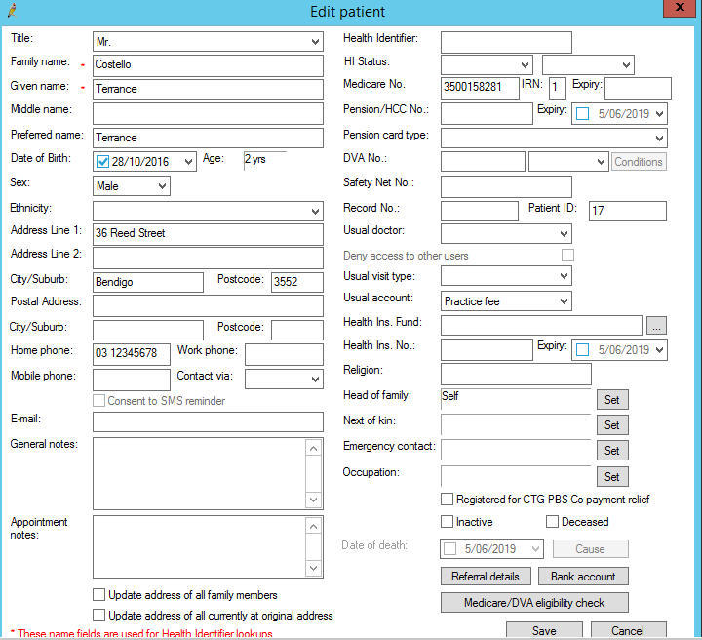

Updating CTG PBS co-payment patient registration in Medical Director
To update the patient’s file with CTG PBS co-payment:
- Open the patient’s file
- Edit the patient’s details
- Tick the box Registered for CTG PBS Co-payment relief
- Click on Save to complete.
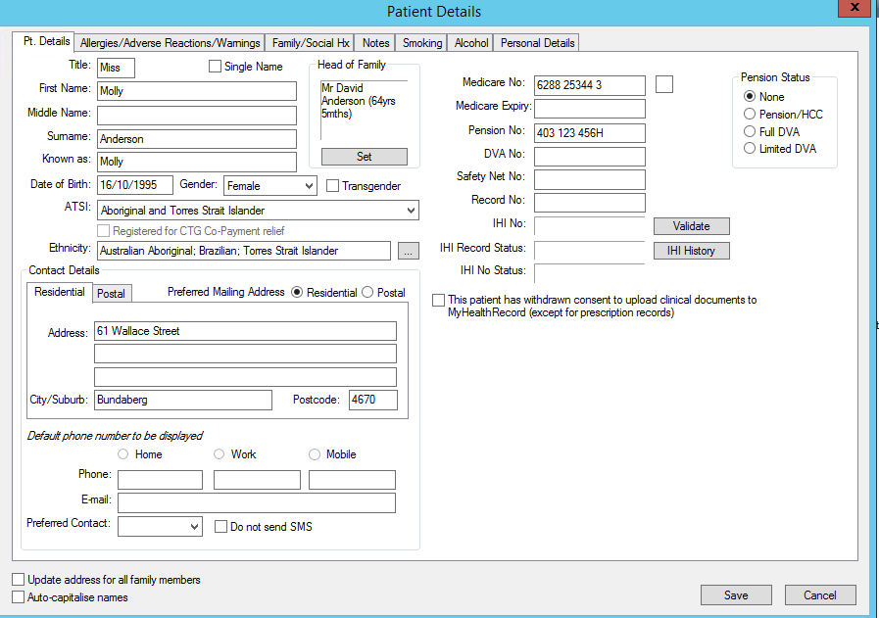

Cultural awareness training
To meet the requirements of the PIP Indigenous Health Incentive, at least two staff members from the practice (one must be a GP) must complete appropriate cultural awareness training within 12 months of the practice signing on to the incentive. For the purpose of the PIP Indigenous Health Incentive, appropriate training is any endorsed by a professional medical college, including those:
- offering Continuing Professional Development (CPD) points, or
- endorsed by the National Aboriginal Community Controlled Health Organisation (NACCHO) or one of its state or territory affiliates.
Practices must provide evidence of training completed.

Activity 4.3 – Cultural awareness training and your practice
Topics to consider | Status | Action to be taken
Have 2 members of your practice team (1 must be a GP), completed Cultural Awareness Training in the past 12 months? | Yes, continue with the activity  No/unsure, see actions to be taken | Participate in training?  Contact  Institute for Urban Indigenous Health
Do you keep a copy of cultural awareness training certificate of attendance? | Yes, you have completed this activity  No, see actions to be taken | Identify a system that will work for your practice on keeping a record of ongoing training. This may be paper based or electronically. A suggestion is to create a folder for each employee and keep a copy of all employee related documentation.
Reflection comments as a result of completing Activity 4.3:
Practice name: Date:
Team member:

Understanding your practice’s cultural profile
How does your practice obtain information about a patient’s cultural background? Are questions about country of birth, ethnicity, language spoken and interpreter required on your new patient form?

RACGP 5th edition Accreditation Standards
As outlined in the RACGP accreditation standards, patients have a right to understand the information and recommendations they receive from their practitioners. Practitioners have a professional obligation to communicate effectively and to understand their patients’ health concerns.

C1.4 A Our practice endeavours to use an interpreter with patients who do not speak the primary language of our practice team.

The RACGP encourages you to identify and record the cultural background of all patients, as this information can be an important indicator of clinical risk factors and therefore help practitioners to provide relevant care.

Before asking a patient any questions about their cultural background, explain that knowing such information helps the practice provide appropriate healthcare. ¹

C7.1F Our practice routinely records the cultural backgrounds of our patients in their patient health record, where relevant.

Number of patients with Country of birth and/or ethnicity recorded

Activity 5.1 – Data collection from CAT4
Complete the below table by collecting data from PenCS Recipe: https://help.pencs.com.au/display/CG/Ethnicity

The aim of this activity is to collect data to determine the number of patients with their Country of birth and/or Ethnicity recorded.

 | Description | Total number
5.1 | Number of active patients who have their ethnicity recorded
5.2 | Number of active patients who have their country of birth recorded

Reflection comments as a result of completing Activity 5.1:
Practice name: Date:
Team member:

Activity 5.2 – Understanding your practice’s cultural profile
The aim of this activity is to increase your understanding of the cultural backgrounds of the patients at your practice.
Description | Status | Action to be taken
After completing activity 5.1 are there any unexpected results with your practice’s cultural profile? | Yes: see actions to be taken  No: continue with activity | Please explain: (for e.g. only 50% of patients have their ethnicity recorded)  How will this information be communicated to the practice team?
Is your practice’s cultural profile similar to other practices in the Brisbane South region (compare information from Benchmarking report)? | Yes: continue with activity  No: see action to be taken | Outline the differences – (for e.g.: we have more/less people of culturally diverse backgrounds than other practices)  How will this information be communicated to the practice team?
Does your practice have a number of patients from specific ethnic groups? (for e.g.: Aboriginal/Torres Strait Islander, Italian, Maori, Sudanese etc | Yes: see action to be taken  No: continue with the activity | Discuss with Western NSW PHN
After reviewing your practice’s cultural profile, are there any changes with the management of your patient’s that you would like to implement over the next 12 months | Yes, set goals and outline in actions to be taken  No, continue with activity | Refer to the “Thinking part” of the introduction module
Do you want to see improvements in recording ethnicity and country of birth in your practice over the next 12 months? | Yes, complete a PDSA process outlining what you will do  No, you have completed this activity | Add this information into the new patient form.  Refer to the “Doing part - PDSA” part of the introduction module

Reflection comments as a result of completing Activity 5.2:
Practice name: Date:
Team member:

Instructions – Recording ethnicity and country of birth in your clinical software (Medical Director)
It is important to record activities in the correct data fields and avoid entering the activities as ‘free text’ in the progress notes. By recording the information in the correct fields, it will:
- Improve efficiency when using Medical Director by reducing the amount of time searching for information in the patient progress notes
- Improve consistency in how data is entered across all patients at the practice
- Allow the Pen CAT4 Audit tool to extract accurate data on patients

Entering ethnicity information in the patient file in Medical Director
- Have the patient file opened
- In the ‘patient details’ screen click on the box with the 3 dots next to ‘Ethnicity’ field

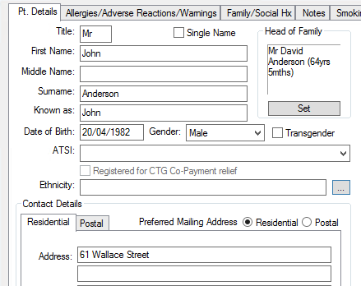

- Select the Ethnicity that is appropriate for the patient and click OK to save.

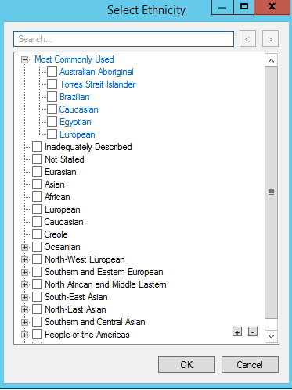

Entering country of birth in the patient file in Medical Director
- Have the patient file opened
- In the ‘patient details’ screen select the ‘Personal Details’ tab
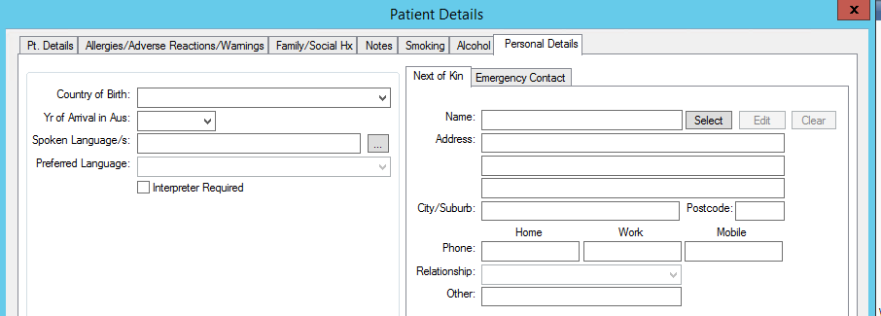
- Enter Country of Birth, year arrival in Australia, spoken languages, preferred languages and if an interpreter is required.

Instructions – Recording ethnicity in your clinical software
(Best Practice)
It is important to record activities in the correct data fields and avoid entering the activities as ‘free text’ in the progress notes. By recording the information in the correct fields, it will:
- Improve efficiency when using Best Practice by reducing the amount of time searching for information in the patient progress notes
- Improve consistency in how data is entered across all patients at the practice
- Allow the Pen CAT4 Audit tool to extract accurate data on patients

Entering ethnicity information in the patient file in Best Practice
- Have the patient file open
- Open the ‘Edit patient’ screen
- Click on the drop-down menu at Ethnicity

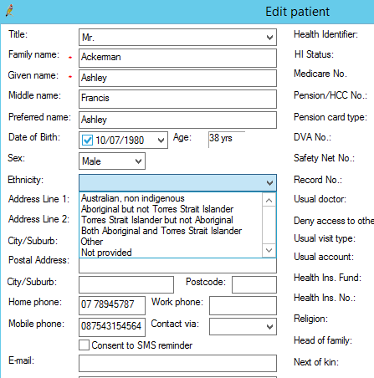

If you select ‘Other’, another screen will appear with a list for you to choose from. Click OK to save.

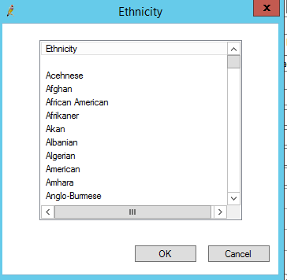

Activity 5.3 – Interpreter services

Activity 5.3 – Interpreter services
 | Status | Action to be taken
Do you include on a patient’s record if they need an interpreter and the language spoken? | Yes, continue with the activity  No/unsure, see actions to be taken | Add this information into the new patient form.
Are all your GPs registered with Translating and Interpreting Services (TIS)? | Yes, continue with the activity  No/unsure, see actions to be taken | Contact TIS 1300 655 820 to check who is registered  If you need to register a GP – more information available on how to register GPs for the service
Do you have the TIS Client Code of all GPs available to relevant staff? | Yes, continue with activity.  No, see actions to be taken | You may wish to have a template stored at reception with the following information:  Interpreter Service  Doctors Priority Line. 1300 131 450  Medical Practitioner name Client Code  Dr (Insert name) (Insert code)  Dr (Insert name) (Insert code)  Dr (Insert name) (Insert code)  Dr (Insert name) (Insert code)  Dr (Insert name) (Insert code)
Do all members of the practice team know the languages spoken by the team (GPs, Nurses, Admin staff)? | Yes, continue with activity.  No, see actions to be taken. | You may wish to have a template stored at reception with the following information  Languages Spoken by the team at (Insert Practice Name)  Practice Team Member Language Spoken  For eg: Mary Smith Italian, Spanish  Please note: multilingual staff should not be used to interpret medical and/or other complex discussions. Qualified interpreters should be used if a patient does not speak English (and you do not fluently speak their language).
Does the practice policy & procedure manual have up to date instructions on when to engage an interpreter and how to contact TIS? | Yes, continue with activity.  No, see actions to be taken. | Update policy and procedure manual to include:  Qualified interpreters should be used if a patient does not speak English (and you do not fluently speak their language). A family member or friend may be used on occasion, for simple day-to-day communication (such as booking an appointment), but a qualified interpreter for medical and/ or other complex discussions is strongly advised.
Are interpreting services discussed as part of the orientation process for new GPs and staff? | Yes, continue with activity.  No, see actions to be taken. | Update orientation process to include interpreting services.  Please note: all practice staff working with the GP including nursing and admin can access free interpreting services using the GPs TIS client code
Does your practice display the National Interpreter Symbol letting patients know they can ask for language assistance? | Yes, continue with activity.  No, see actions to be taken. | obtain a copy of the symbol
Do you have in your practice (reception, waiting room, consultation rooms), language cards so patients can point to their language and you can arrange an interpreter? | Yes, continue with activity  No, see actions to be taken | 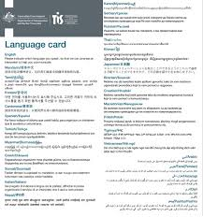  obtain copies of the language cards
Are relevant team members aware of the online Appointment Reminder Translation Tool? | Yes, continue with activity  No, see actions to be taken. | Notifiy relevant team members of the avaibility of the Appointment Reminder Translation Tool
Do you have patient information brochures available in multiple languages? | Yes, continue with activity  No, see actions to be taken | To find translated resources see:  www.healthtranslations.vic.gov.au/  www.refugeehealthnetworkqld.org.au/translated-resources/
Are there any modifications with using interpreting services you would like to make at your practice? | Yes, complete a PDSA process outlining what you will do  No, you have completed this activity | Refer to the Model for Improvement at the end of this document.
Reflection comments as a result of completing Activity 5.3:
Practice name: Date:
Team member:

Activity 5.4 - Referrals to other health professionals
When referring your patient to another healthcare provider, it’s important to clearly tell that provider that they will need language assistance. This ensures the patients receive prompt service and there are no barriers in receiving the appropriate care.

Activity 5.4 – Patient referrals
 | Status | Action to be taken
Do all referrals clearly tell the other provider that the patient will need language assistance? | Yes, continue with the activity  No/unsure, see actions to be taken | Discuss at your next team meeting how this can be achieved  □ Update personal details in patient details for Medical Director users to ensure year arrived in Australia, languages spoken, and preferred language are documented and mark the box of interpreter required as appropriate  Update standard referral templates to include interpreter required is included
Reflection comments as a result of completing Activity 5.4:

Practice name: Date:
Team member:

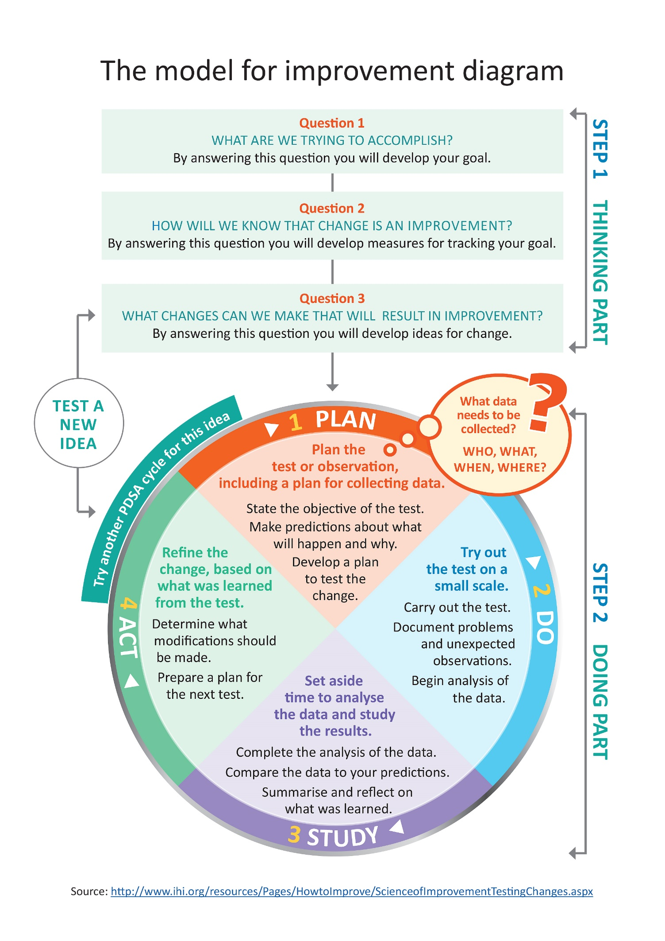

Model for Improvement and PDSA worksheet EXAMPLE

Step 1: The Thinking Part - The 3 Fundamental Questions

Practice name: | Date:
Team member:
Q1. What are we trying to accomplish? (Goal)
By answering this question, you will develop your goal for improvement
Our goal is to:
- Ensure all patients taking 5 or more medications has a Home Medication Review completed every 12 months.
This is a good start, but how will you measure whether you have achieved this goal? The team will be more likely to embrace change if the goal is more specific and has a time limit.
So, for this example, a better goal statement would be:
Our S.M.A.R.T. goal is to:
- Increase the proportion of our active Diabetes patients, taking 5 or more medications having a Home Medication Review completed by 10% by 31 July.
Q2. How will you know that a change is an improvement? (Measure)

By answering this question, you will develop MEASURES to track the achievement of your goal.
E.g. Track baseline measurement and compare results at the end of the improvement.
We will measure the percentage of active patients with Diabetes who have had a Home Medication Review completed. To do this we will:
A) Identify the number of active patients with Diabetes
B) Identify the number of active patients with Diabetes who have had a Home Medication Review
B divided by A x 100 produces the percentage of patients with Diabetes who have had a Home Medication Review
Q3. What changes could we make that will lead to an improvement? (List your IDEAS)

By answering this question, you will develop the IDEAS that you can test to achieve your CHANGE goal.
You may wish to BRAINSTORM ideas with members of our Practice Team.
Our ideas for change:
- Using CAT4, identify active patients with Diabetes, taking 5 or more medications who have not had a Home Medication Review this year
- Identify patients from list exported from CAT4 and send SMS reminder
- Source and provide endorsed patient education resources on Home Medication Review (in waiting rooms, etc)
- Run an awareness campaign for medication safety
The team selects one idea to begin testing with a PDSA cycle

Note: Each new GOAL (1st Fundamental Question) will require a new Model for Improvement Guide
Source: Langley, G., Nolan, K., Nolan, T., Norman, C. & Provost, L. 1996, The Improvement Guide, Jossey-Bass, San Francisco, USA.
Model for Improvement and PDSA worksheet EXAMPLE
Step 2: The Doing Part - Plan, Do, Study, Act
You will have noted your IDEAS for testing when you answered the third Fundamental Question in Step 1
You will use this sheet to test an idea.

PLAN |  |  | Describe the brainstorm idea you are planning to work on. (Idea)
Plan the test, including a plan for collecting data |  |  | What exactly will you do? include what, who, when, where, predictions and data to be collected
Idea: Using CAT4, identify active patients with Diabetes, taking 5 or more medications who have not had a Home Medication Review this year
What: Mary will conduct a search on CAT4 and identify active patients with Diabetes, taking 5 or more medications who have not had a Home Medication Review recorded this year.
Who: Receptionist (Mary)
When: Begin 20 May
Where: at the practice in Dr Bills room
Prediction: 20% of the active Diabetes patient population on 5 or more medication will have had a Home Medication Review this year.
Data to be collected: Number of active Diabetes patients on 5 or more medications and number of active Diabetes patients on 5 or more medications who have not had a Home Medication Review completed this year.
DO | Who is going to do what? (Action)
Run the test on a small scale | How will you measure the outcome of your change?
Completed 20 May – the receptionist contacted Western NSW PHN for support with the PenCS CAT4 search and the export function. The data search was conducted very quickly, with the receptionist being upskilled to conduct further relevant searches.
STUDY |  | Does the data show a change? (Reflection)
Analyse the results and compare them to your predictions |  | Was the plan executed successfully?  Did you encounter any problems or difficulty?
A total of 5 active patients (12%) with Diabetes on 5 or more medications have had a Home Medication review recorded this year = 8% lower than predicted.
ACT |  |  |  | Do you need to make changes to your original plan? (What next)  OR Did everything go well?
Based on what you learned from the test, plan for your next step |  |  |  | If this idea was successful you may like to implement this change on a larger scale or try something new  If the idea did not meet its overall goal, consider why not and identify what can be done to improve performance
- Identify patients from list exported from CAT4 and send SMS recall
- Create a PenCS Topbar prompt to ensure all patients with Diabetes on 5 or more medications have a Home Medication Review offered and result recorded at their next appointment. Review this by 31 July (in 2 months’ time) to determine if there has been an increase in the number of patients with HMR recorded.
- Ensure the clinical team know how to complete the referral and medication plan in the medical software.
- Remind the whole team that this is an area of focus for the practice.

Repeat Step 2 for other ideas – What idea will you test next?

Model for Improvement and PDSA worksheet template

Step 1: The Thinking Part - The 3 Fundamental Questions

Practice name: | Date:
Team member:
Q1. What are we trying to accomplish? (Goal)
By answering this question, you will develop your GOAL for improvement
Q2. How will you know that a change is an improvement? (Measure)
By answering this question, you will develop MEASURES to track the achievement of your goal.
E.g. Track baseline measurement and compare results at the end of the improvement.
3. What changes could we make that will lead to an improvement? (List your IDEAS)
By answering this question, you will develop the IDEAS that you can test to achieve your CHANGE goal.
You may wish to BRAINSTORM ideas with members of our Practice Team.
Idea:

Idea:

Idea:

Idea:

Note: Each new GOAL (1st Fundamental Question) will require a new Model for Improvement plan.
Source: Langley, G., Nolan, K., Nolan, T., Norman, C. & Provost, L. 1996, The Improvement Guide, Jossey-Bass, San Francisco, USA.
Model for Improvement and PDSA worksheet template

Step 2: The Doing Part - Plan, Do, Study, Act cycle
You will have noted your IDEAS for testing when you answered the third Fundamental Question in Step 1
You will use this sheet to test an idea.

PLAN | Describe the brainstorm idea you are planning to work on. (Idea)
Plan the test, including a plan for collecting data | What exactly will you do? Include what, who, when, where, predictions and data to be collected
DO | Who is going to do what? (Action)
Run the test on a small scale | How will you measure the outcome of your change?
STUDY | Does the data show a change? (Reflection)
Analyse the results and compare them to your predictions | Was the plan executed successfully?  Did you encounter any problems or difficulty?
ACT | Do you need to make changes to your original plan? (What next)  OR Did everything go well?
Based on what you learned from the test, plan for your next step | If this idea was successful you may like to implement this change on a larger scale or try something new.  If the idea did not meet its overall goal, consider why not and identify what can be done to improve performance.
Repeat Step 2 for other ideas - What idea will you test next?
First floor, Building 20, Garden City Office Park, 2404 Logan Road, Eight Mile Plains QLD 4113
PO Box 6435, Upper Mt Gravatt QLD 4122 T: 3864 7555 or 1300 467 265 | F: 3864 7599
bsphn.org.au | ABN 53 151 707 765

¹ Australia joins international push to halve medication errors article from Australian Commission on Safety & Quality in Healthcare

