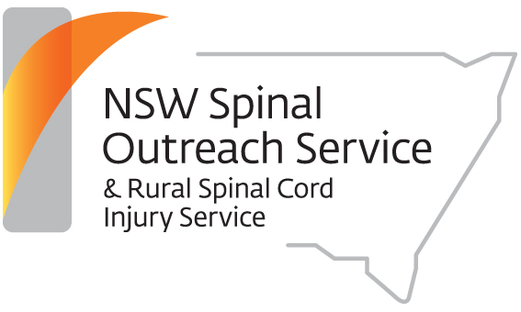

RSCIS (Rural Spinal Cord Injury Service / Spinal Outreach Service) and RHOF (Rural Health Outreach Fund) present:
SPINAL CORD INJURY EDUCATION SESSION

Targeting: Nurses, Occupational Therapists, Physiotherapists and Social Workers
What: A choice of 2 workshops - Upper Limb Workshop FOLLOWED BY Sexuality Workshop
When: Thursday 27th June 2019 – TIME 0900am- 3.30PM
Where: University of Sydney RURAL CLINICAL SCHOOL, Audley Building Function Room
1502 Forest Road Cnr Acacia Way and Canobolas Drive, Bloomfield Campus ORANGE
TIME | PROGRAM
9:00 am – 12:45pm  including a break for morning tea | UPPER LIMB WORKSHOP □  This workshop targets occupational therapists and physiotherapists  The prevalence of upper limb pain in people with a spinal cord is high - 68% complain of some type of upper extremity pain at any one time...  The focus of the workshop is on preventative strategies. Other topics that will be covered include a refresher on upper limb anatomy and biomechanics as well as common upper limb musculo-skeletal injuries and their management. | Lyndall Katte, Senior Physiotherapist, NSW Spinal Outreach Service  Anne Willey, Senior Occupational Therapist, NSW Spinal Outreach Service
12:45pm-1.15pm
1:15pm – 3:30pm | SEXUALITY WORKSHOP □  This workshop is suitable for all disciplines, and is particularly relevant for nurses and social workers  This workshop looks at the impact of a spinal cord injury (SCI) on a person’s sexuality. We will discuss strategies to help clients adjust to changes, and practical, physical and pharmacological interventions available. The workshop aims to increase the participant's confidence levels in addressing this important aspect with their client. | Professor James Middleton Senior Spinal Specialist,  NSW Spinal Outreach Service  Lorna Layson, Clinical Nurse Specialist, NSW Spinal Outreach Service  Angela Pong, Senior Social Worker, NSW Spinal Outreach Service
This workshop is free. Morning tea will be provided during the morning workshop and lunch for people who attend both workshops only so please ensure you tick both boxes.
Please contact Melissa McCormick on ph: 9808 9666 if you have any queries.
RSVP: must be received by Friday 14TH June 2019 as we require it for catering, correspondence and the printing of resources
to Melissa McCormick/Anne Willey, RSCIS Managers either via email: ruralscied@royalrehab.com.au or fax: 8078 6688
NB: We will acknowledge the receipt of your “RSVP” via email – if you have not heard from us by the RSVP date, please call ph: 9808 9666.
YOUR DETAILS:
Name and Occupation ________________________________________________________________________________________________________________________________________________________________________
Workplace and Address ______________________________________________________________________________________________________________________________________________________________________
Contact details (email and phone no)________________________________________________________________________________________________________________________________________________________
Dietary requirements – please tick: normal diet gluten free vegetarian

