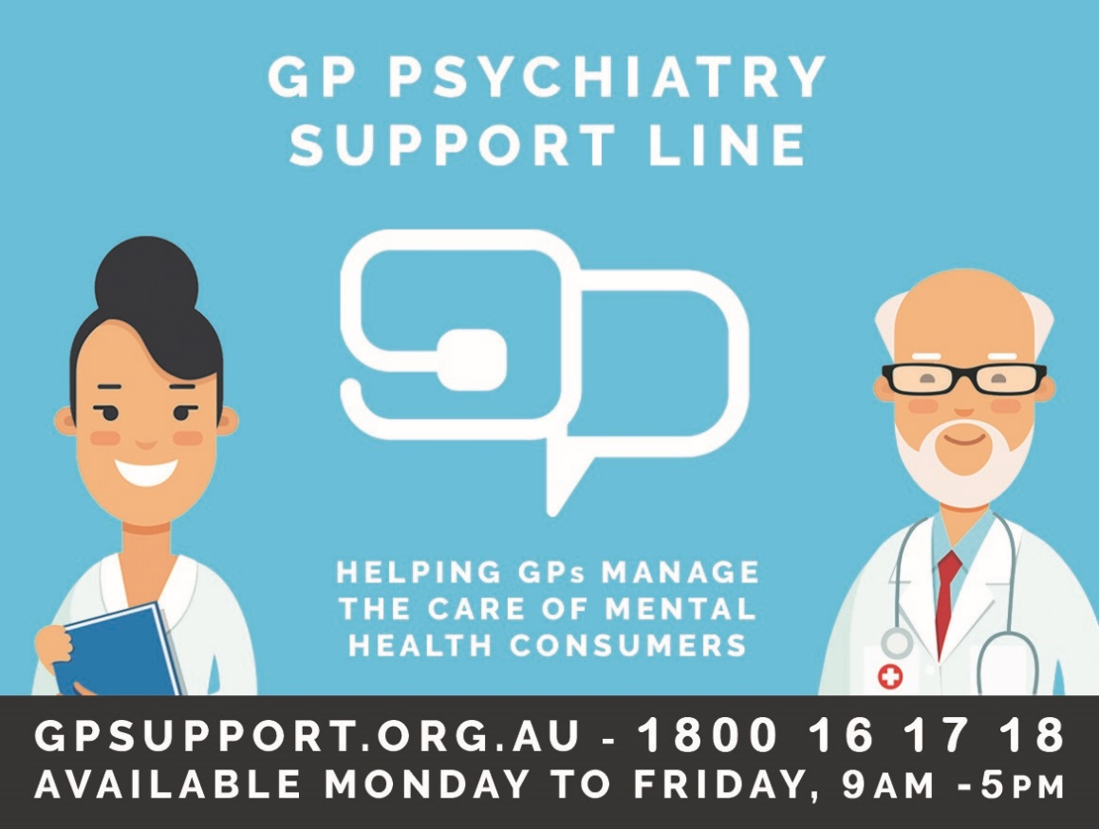

New reminder cards are on their way!
Have you heard about the Psychiatry Support Line? It’s a free service exclusively for GPs to help you manage the care of mental health consumers.
Staffed by psychiatrists, the Psychiatry Support Line was established in July 2018 in response to GPs indicating they would like timely access to psychiatry expertise. It’s not about triaging or referring consumers to a psychiatrist, but rather ensuring that consumers can be treated within primary care, under the guidance of their GP.
The service is free, and available Monday to Friday, 9am-5pm.
How to access the service
Register at www.gpsupport.org.au – it takes two minutes. You can also register by phone if you prefer.
GPs can call 1800 16 17 18 between 9am and 5pm, Monday to Friday.
You can also submit your enquiry via secure messaging to ProCare Waratah (via Argus, Medical Objects, HealthLink, E-Referral), with the option of a call back or reply via secure messaging.

