Name of Practice: Date:

QI Activity Description

What will a successful outcome look like
(10-word elevator pitch)?
How will you measure success?

What is your initial benchmark?

Who will be leading this activity?

Resources and Education required?

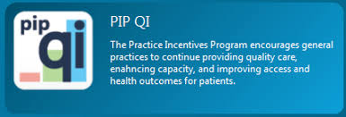

Quality Improvement Activity Process & Timeframe
Step | What | Who | When
1
2
3
4
5
6
7
8

Upon completion
- What are the lessons learnt from this Quality Improvement Activity?
- Do we need to review or extend the activity?
- Is this Quality Improvement Activity completed?

